CREATING IBM CLOUD SERVICE

|  |  |
| --- | --- |
|  |  |
| Team ID | PNT2022TMID28961 |
| Project Name | Gas leakage monitoring and alerting system for  industries |

# AIM:

To create IBM Cloud Service.

# STEPS TO BE FOLLOEWD

Step 1: Visit to the ICT Academy Skills Network Page by clicking on the link given below:

Link:

https://courses.ictacademy.skillsnetwork.site/courses/course-v1:IBMDeveloperSk illsNetwork+CC0103EN+v3/course/

Step 2: Click on register.

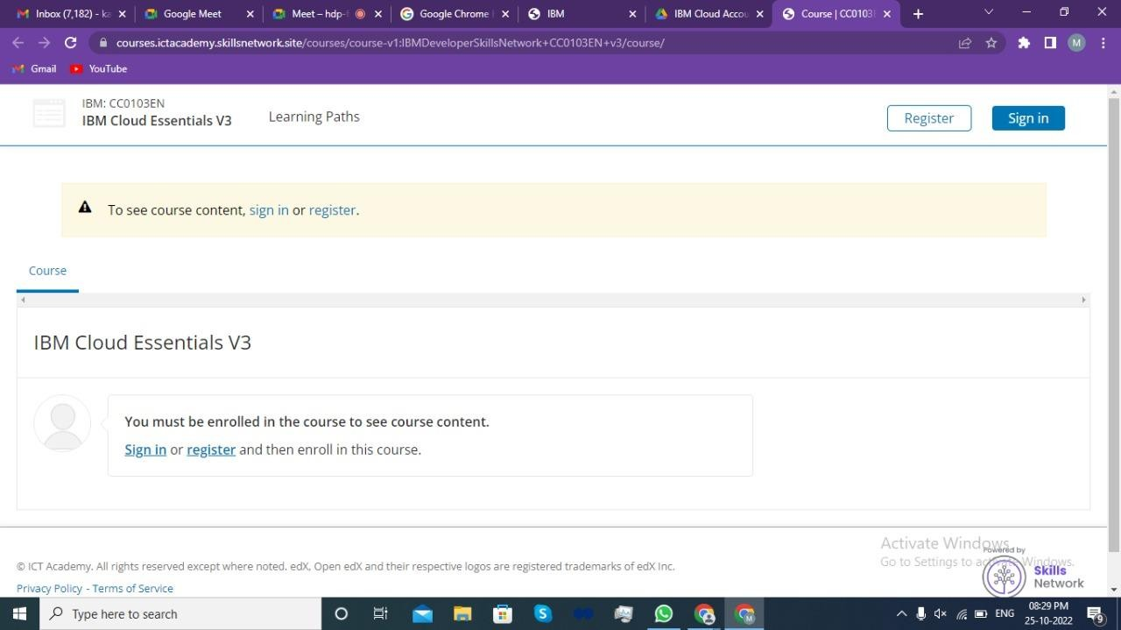

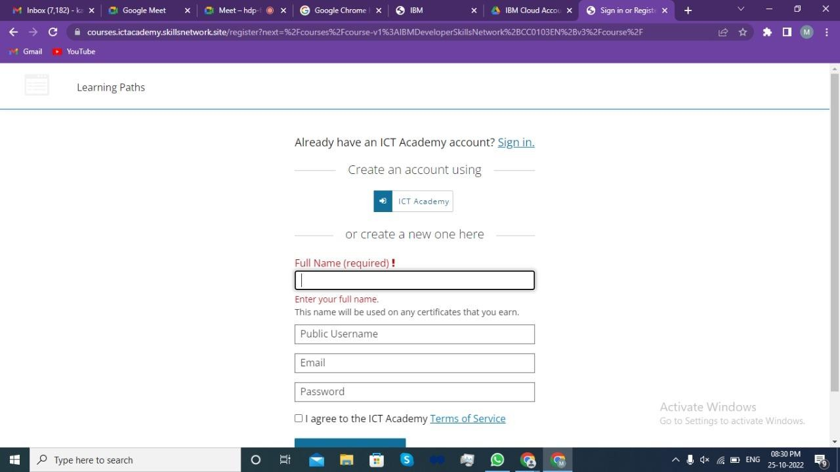

Step 4: Click on Enroll Now button to enter the course.

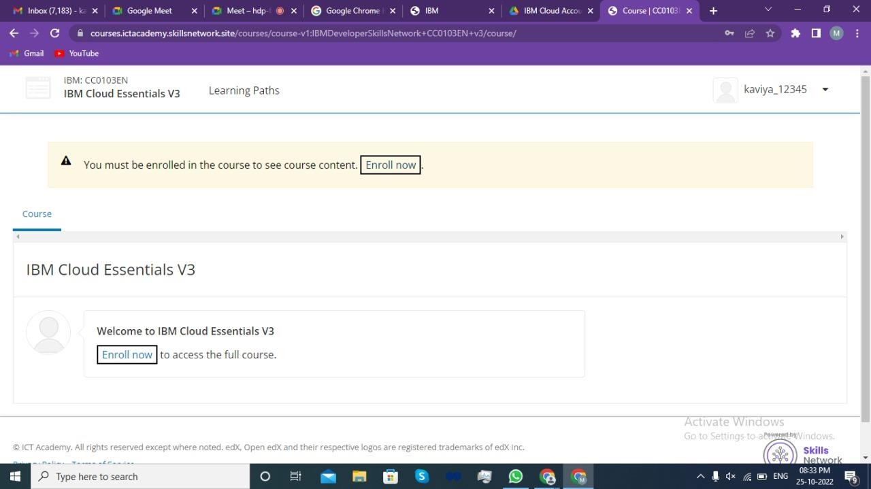

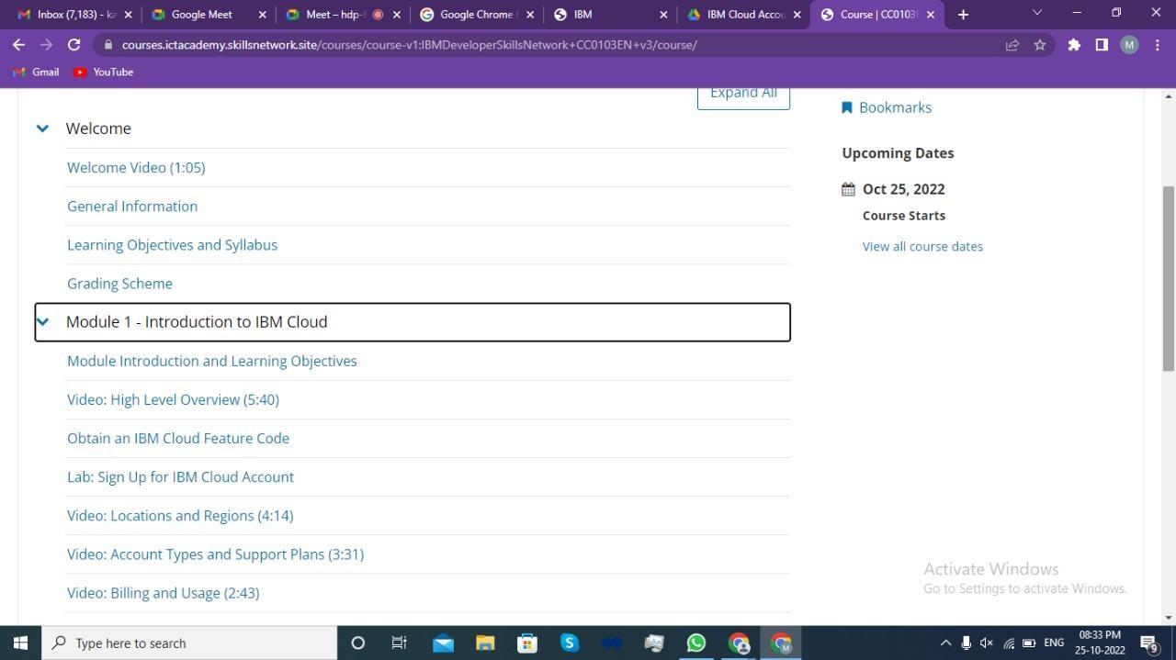

Step 6: Click on Obtain an IBM Cloud Feature Code.

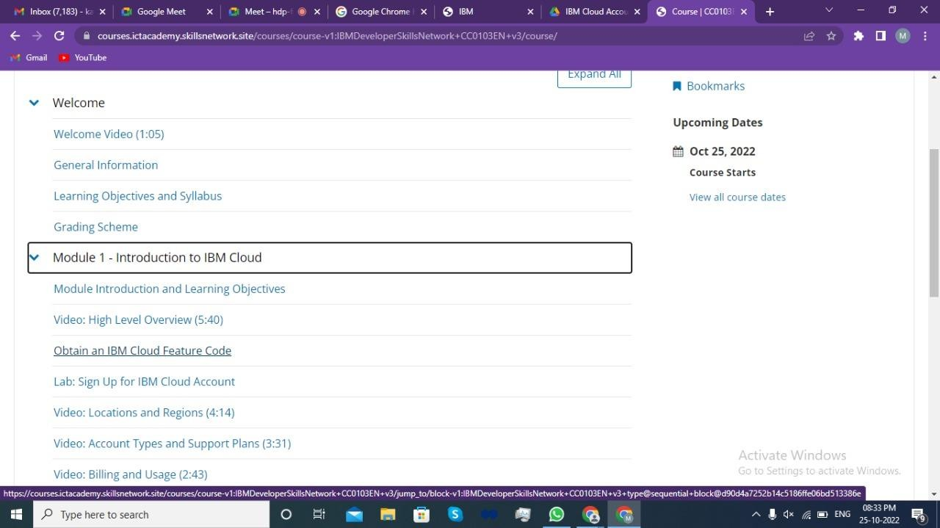

account.

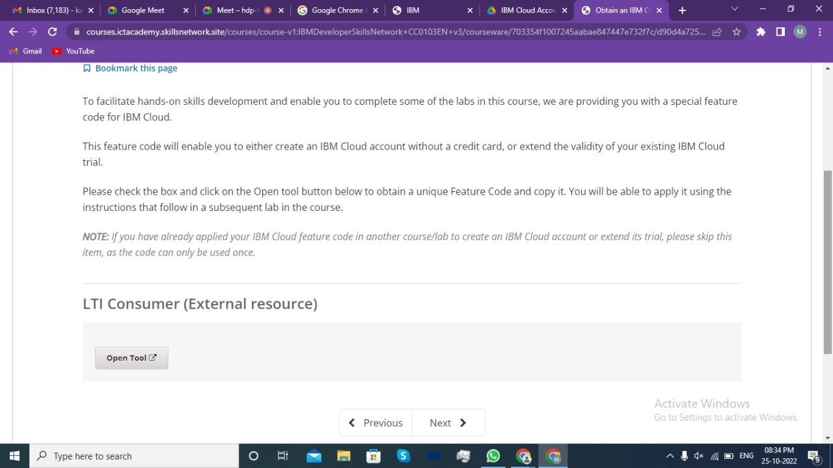

Step 8: Click ok on the popup message to proceed to the next page.

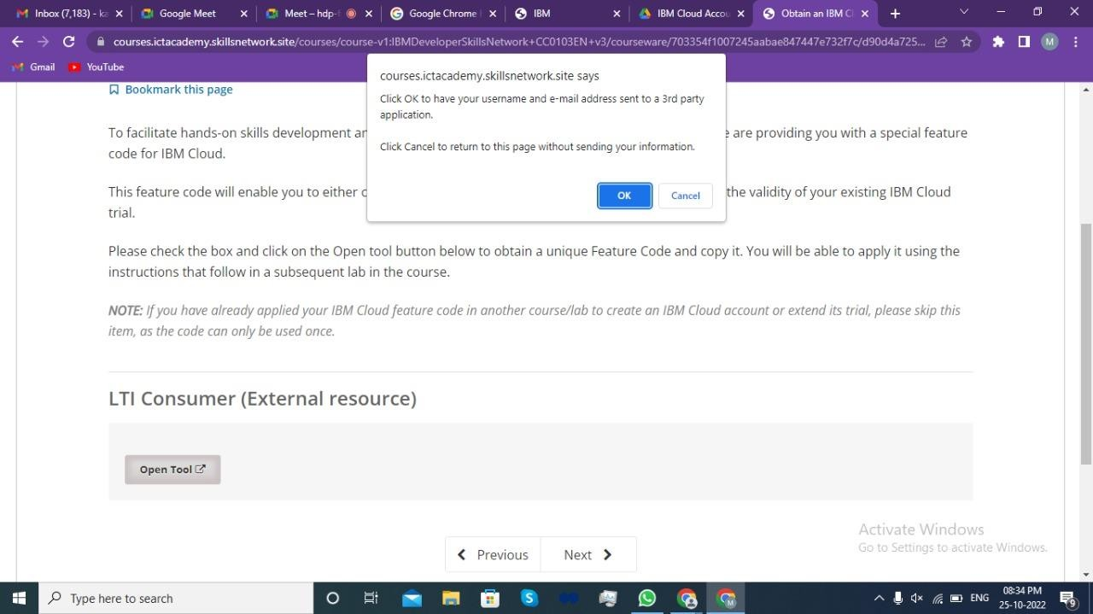

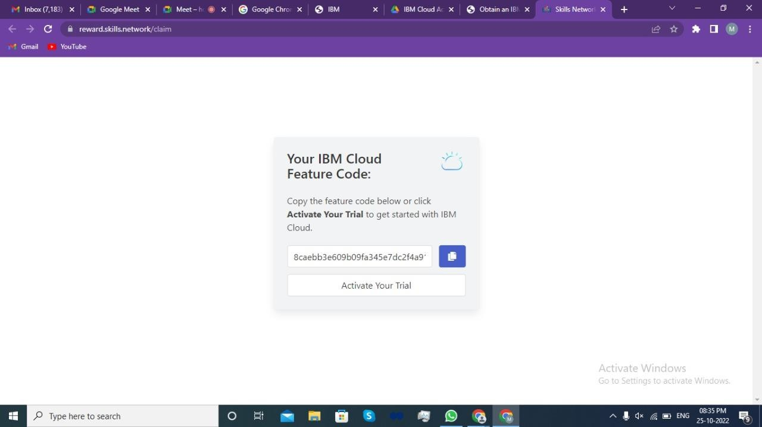

Step 10: Provide the email id & password used for ICT Academy account creation and click on next to get the OTP on the registered email id.

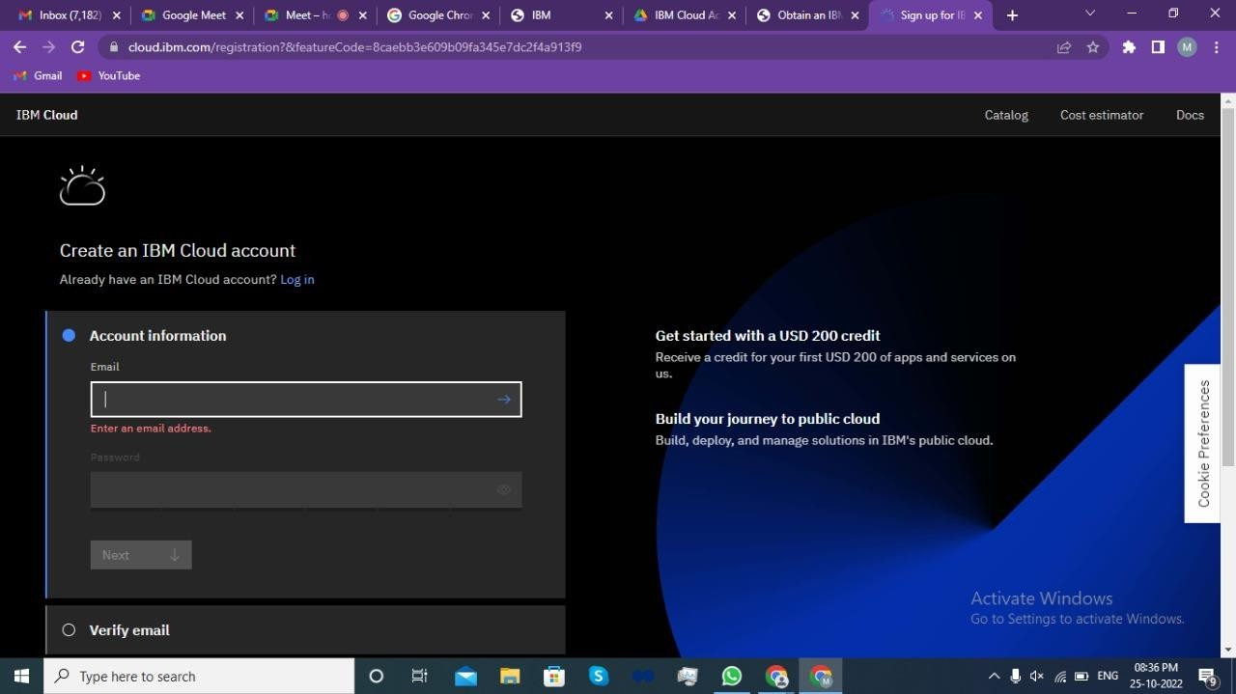

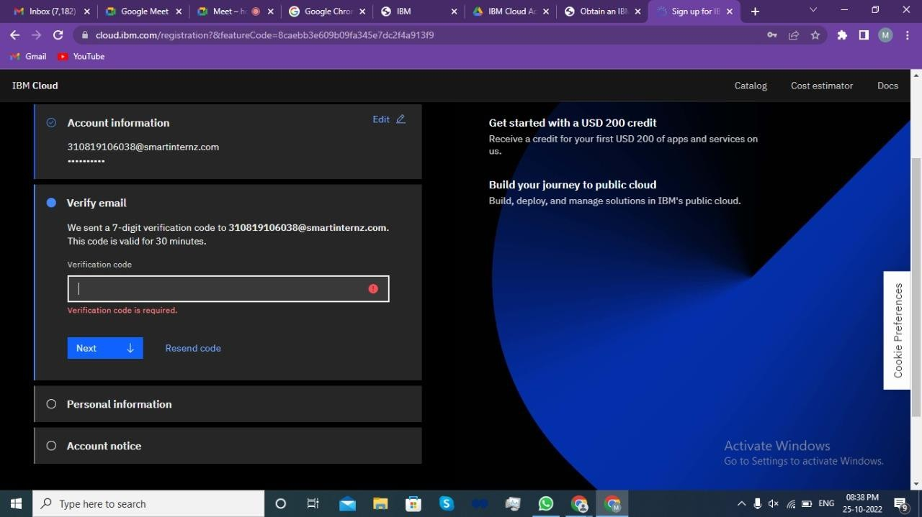

Step 12: Provide personal information and click on next.

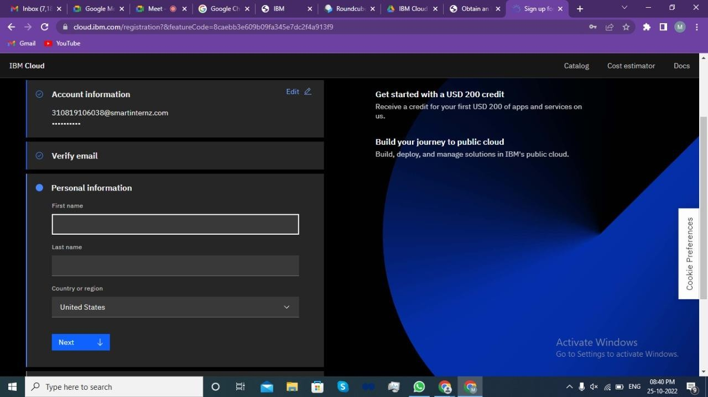

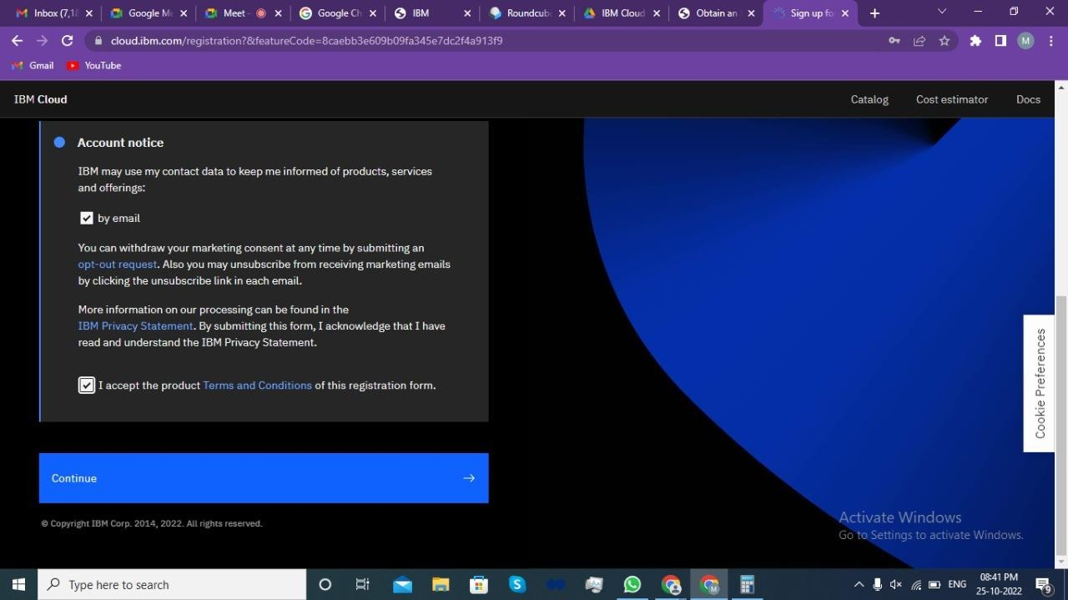

Step 14: Review account privacy notice mark the checkbox then click on continue.

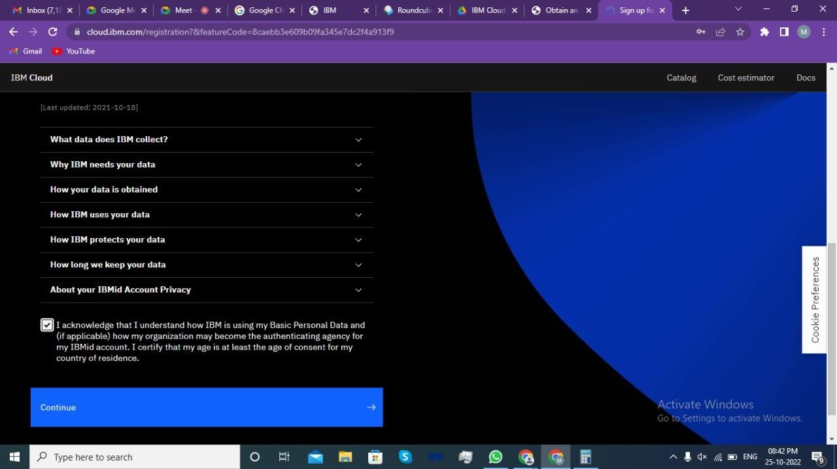

https://[www.ibm.com/academic/home](http://www.ibm.com/academic/home)

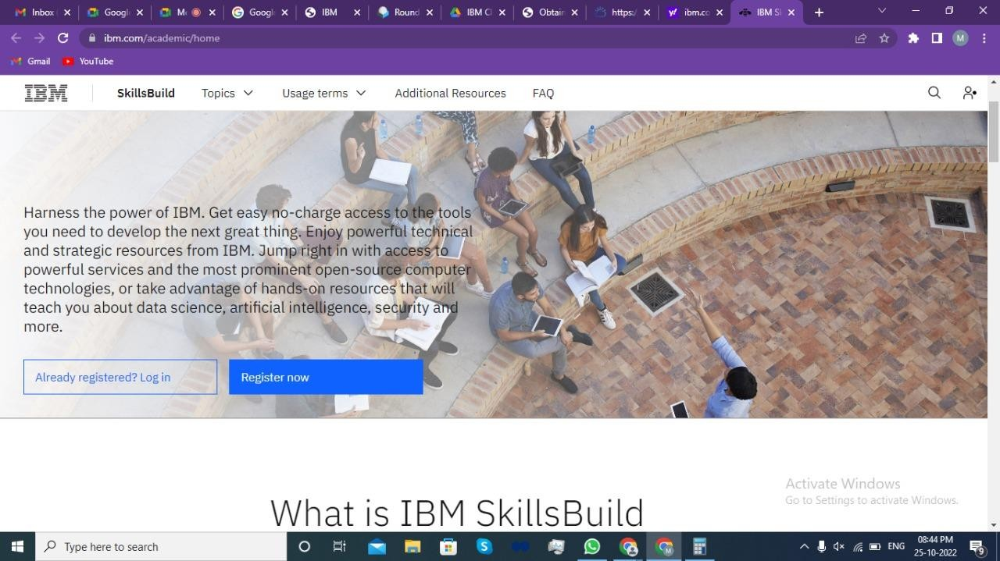

Step 16: Click on Register Now.

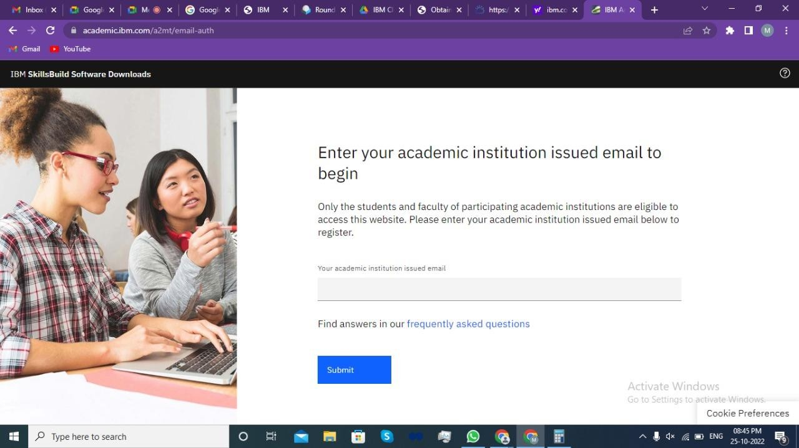

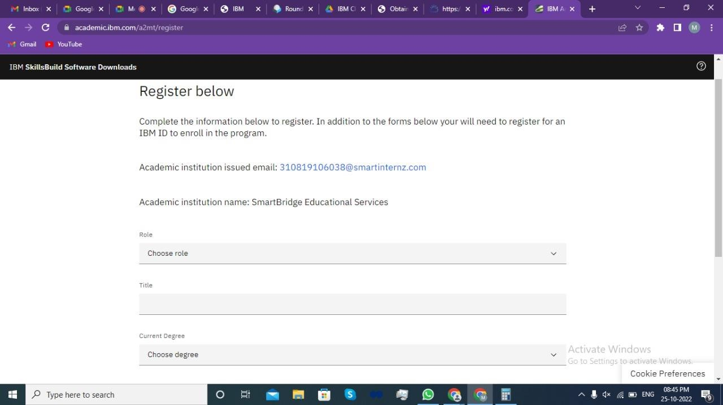

Step 18: Agree the Terms and Conditions and Register.

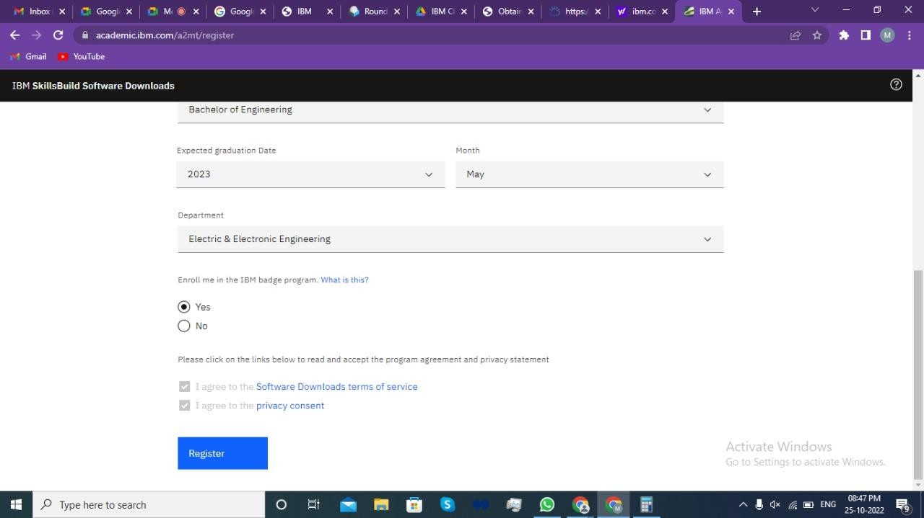

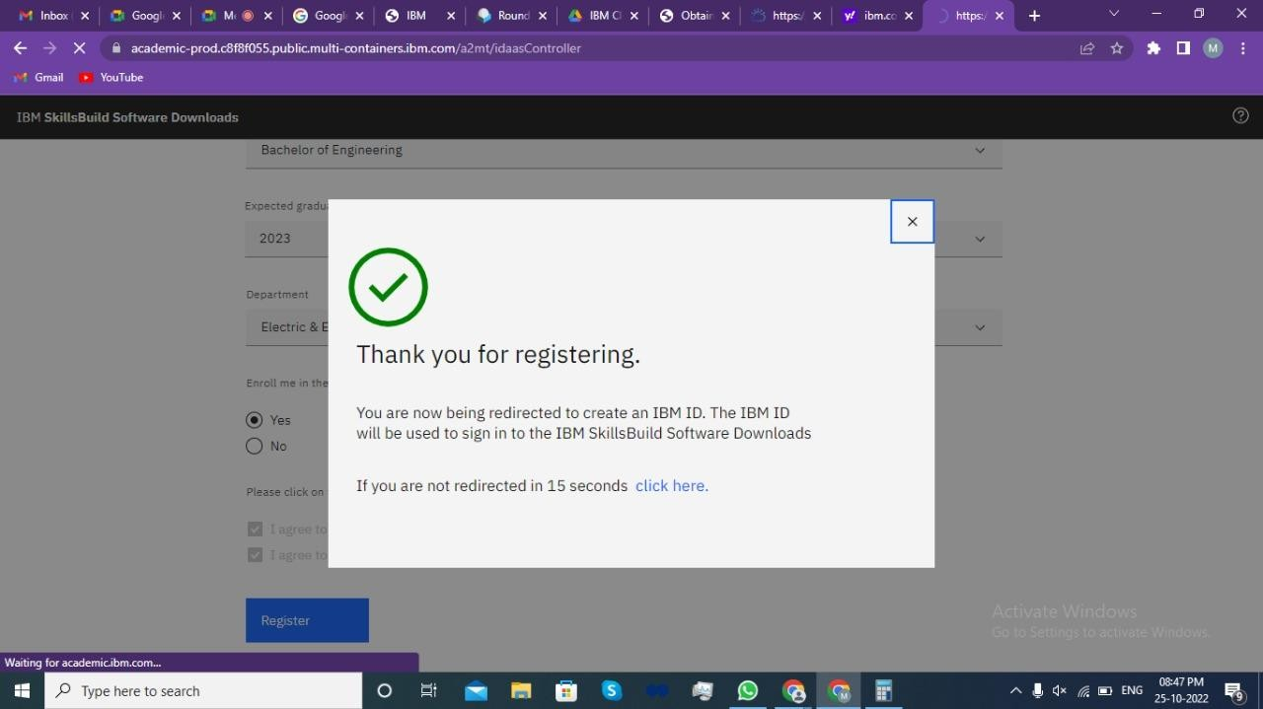

Step 20: Click on IBM Cloud.

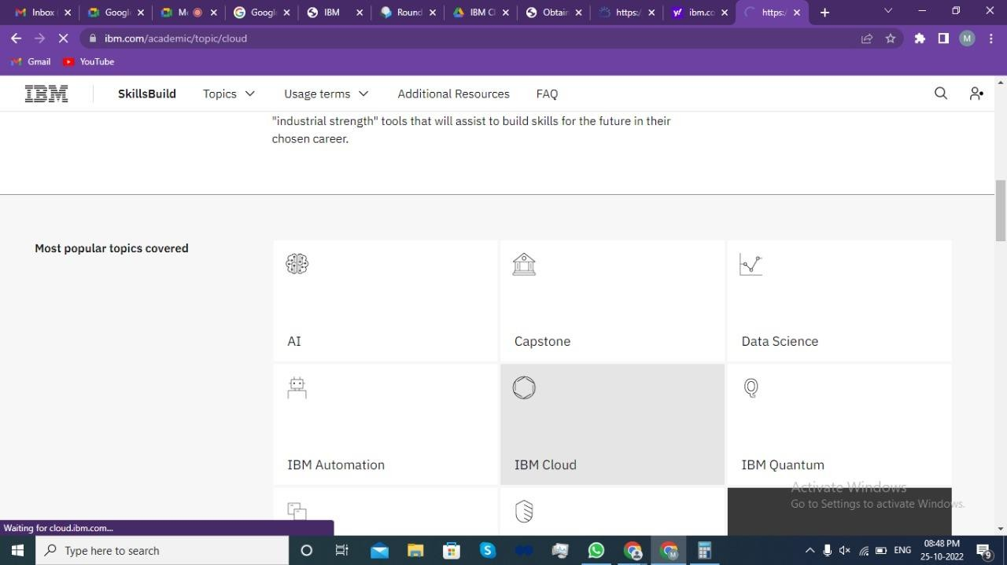

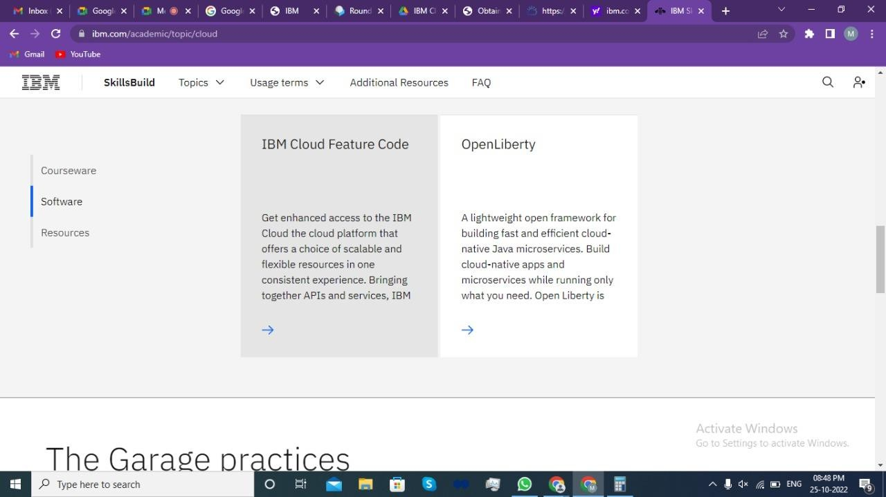

Step 22: Click on Request Feature Code.

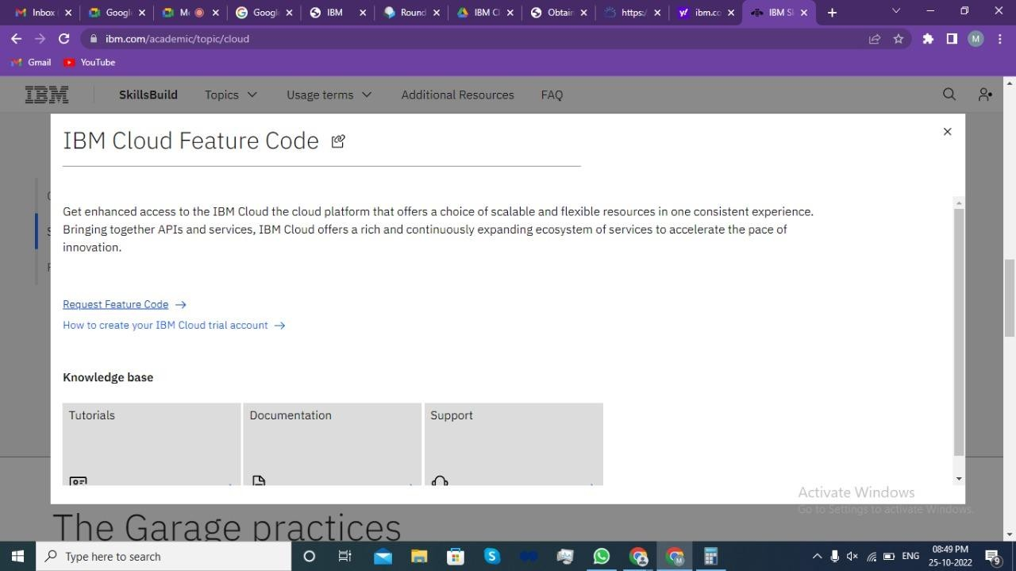

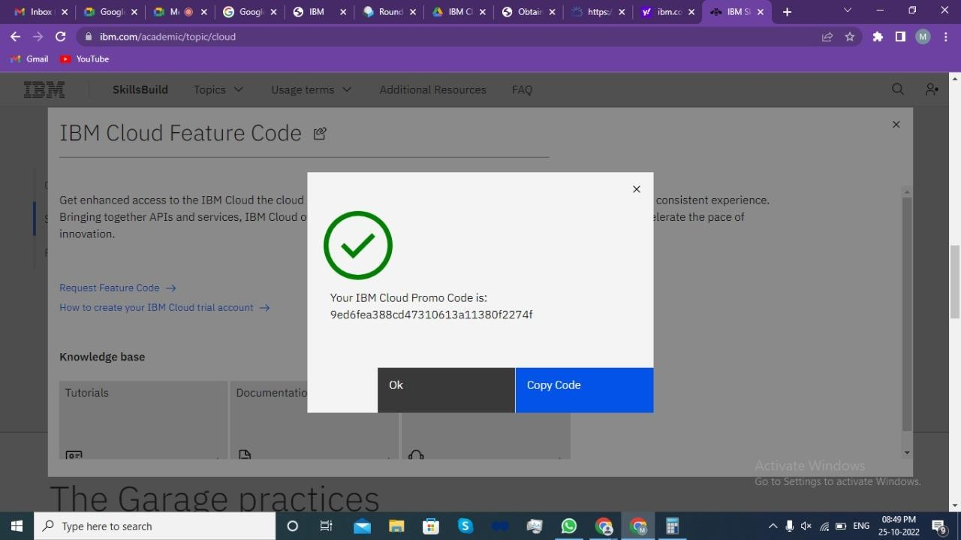

Step 24: Paste the Code and click on create account.

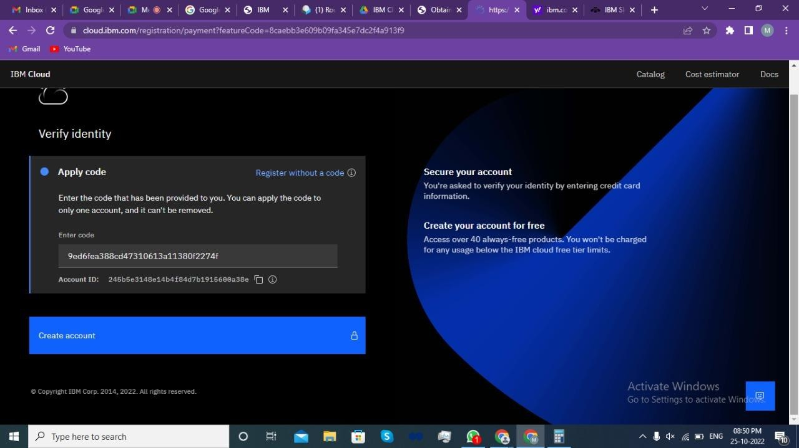

Cloud account.

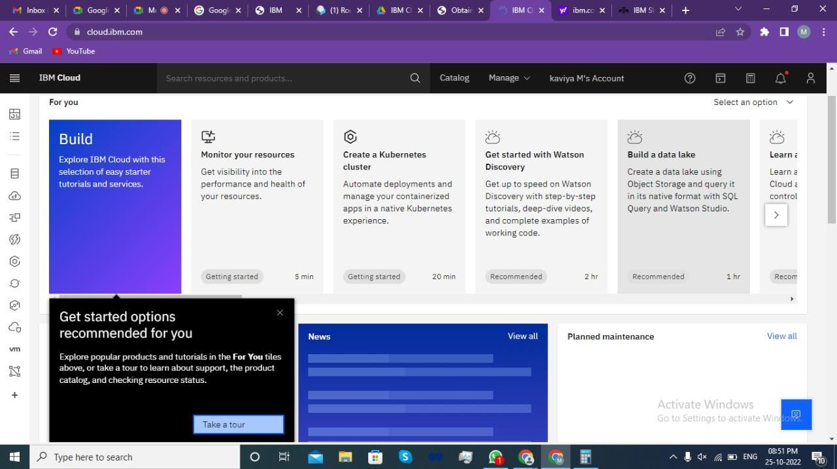

# Result:

An IBM Cloud Service created Successfully.